**QUANTIFYING THE VALUE OF POTENTIAL FEEDSTOCKS FOR AD, THE IMPORTANCE OF BIOCHEMICAL METHANE POTENTIAL TESTING**

Burgess, A. and Smyth, M.

Aqua Enviro, UK,

Corresponding Author Tel. 01924242255; 07584438220

Email: [andyburgess@aquaenviro.co.uk](mailto:andyburgess@aquaenviro.co.uk)

**Abstract**

Due to the current competition and barriers to growth in the UK AD market, understanding the biodegradability and methane potential of Feedstocks prior to treatment or assigning appropriate gate fee is paramount. Previous studies have shown theoretical estimations of the BMP overestimate the methane yield obtainable. A specific BMP test methodology was reviewed regarding its limitations, uses and how the results can be expressed and interpreted. This study used ~10 years of BMP data from samples taken throughout the UK, spanning across all AD sectors. A high degree of variability was discovered between multiple samples of the same feedstock category, this confirmed the importance of quantifying the BMP prior to assigning a gate fee or accepting the material. Once an accurate BMP result is achieved, the resulting data can be used to aid plant design, improve feedstock management and quantify the revenue obtainable from a certain feedstock.

**Keywords**

Anaerobic digestion; Biochemical Methane Potential; BMP.

**Introduction**

There are now 540 AD plants in the UK: 283 in Agriculture; 159 sewage sludge; 90 municipal/commercial; 40 Industrial.

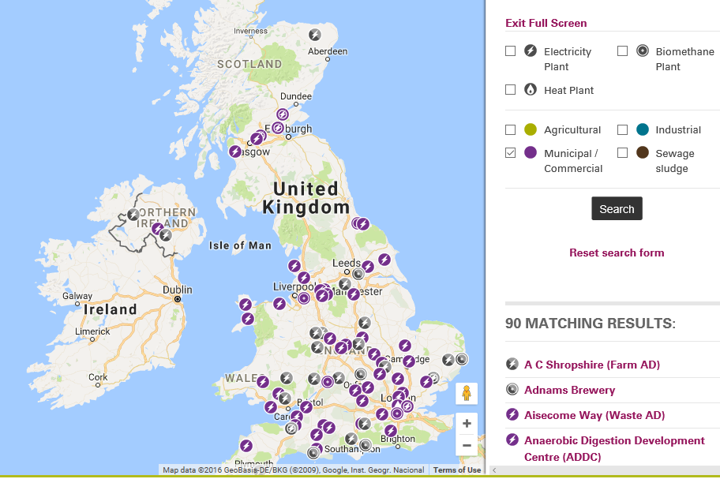

**Figure 1: AD plant Map for the United Kingdom, Municipal / Commercial sector (ADBA, 2016)**

Recent AD market research undertaken by WRAP has highlighted that the high number of plants is contributing to a decrease in the availability of feedstocks and a reduction in gate fees. In certain areas of the UK a £0 gate fee is in operation to ensure that feedstock availability is not limited over weekends or holiday periods (Wrap 2016).

Other barriers to growth for the AD market include the removal and reduction of government incentives, including a ~40% decrease in feed in tariff (FIT) for the food waste sector which has been implemented, also renewable obligation (RO) is set to close to new Municipal AD plants in March 2017 (Morton, C. 2016)

Understanding the value of a feedstock (Biochemical Methane Potential Testing, BMP) is therefore more important than ever and once this is known it becomes possible to identify potential inhibitory wastes, improve feedstock management and develop a gate fee charging model which enables the site to set competitive rates.

This paper looks at the BMP test, values from different feedstocks, how BMP values can be interpreted and incorporated into a feedstock calculator to help determine a gate fee charging model.

**BMP Test Methodology**

A variety of methods exist which provide quantitation of the theoretical biochemical methane potential such as the Buswell (Symons and Buswell, 1933) and Mcarty (McCarty,1972) methods, these calculate the energy value based on the chemical composition of the feedstock and assume all organic material is converted to methane.

Theoretical estimations of the biochemical methane potential are a useful indicative tool, but do not take into account biodegradability, variability between samples with the same names or potential inhibitory properties that the substrate may possess.

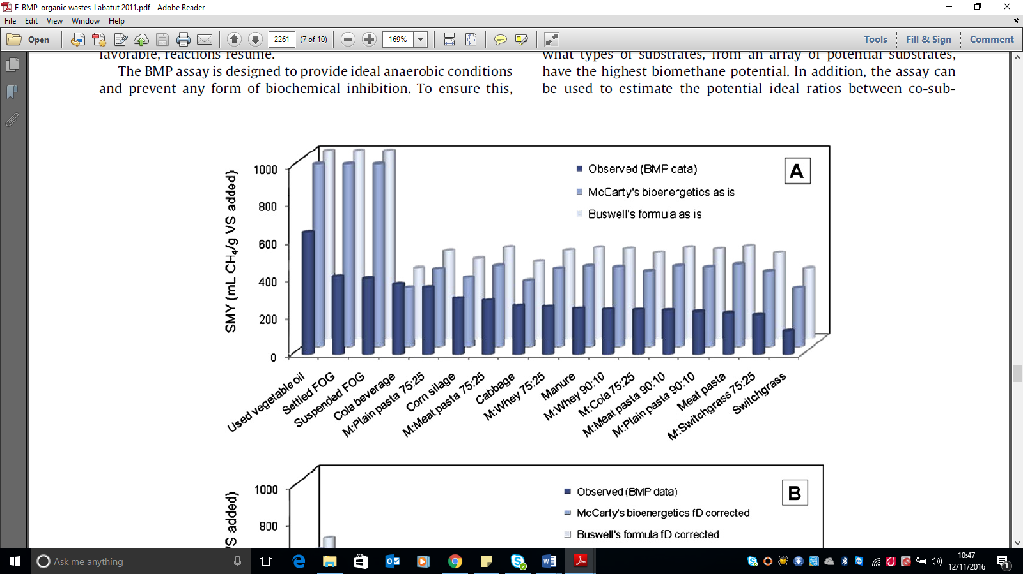

**Figure 2: Observed and estimated methane yields of 17 selected substrates using McCarty’s bioenergetics and Buswell’s formula (**Labatut, R. *et al* 2011)

An accurate quantitation of the actual BMP value is crucial when assigning an appropriate gate fee to potential feedstocks for AD, as actual BMP testing provides a better understanding of the substrates biodegradability, methane yield and potential inhibitory properties (Wellinger, A. 2013)

To ascertain the quantity of test material required for the BMP assay the mass of volatile solids (VS) or Chemical oxygen demand (COD) is first determined. Specific methods used were taken from standard methods, VS was analysed gravimetrically by drying the samples at 105oC for 24 hours to determine the % Dry solids, followed by 2 hours at 5500C to quantify the %VS content. Chemical oxygen demand was quantified via colourimetry, using test kits which digest the organic material within a sample using potassium dichromate in sulfuric acid.

**BMP experimental method**

The BMP experimental methodology applied in this study was based on the protocol outlined in the “amenability of sewage sludge to anaerobic digestion 1977, methods for the examination of waters and associated materials” (Standing Committee of Analysts, 1977).

By quantifying the methane volume and concentration from a known mass of anaerobic seed and test material, the potential methane yield in terms of L.CH4/Kg VS or L.CH4/Kg COD applied can be determined.



**Figure 3: BMP equipment diagram**

Schematic for the BMP equipment used is displayed in figure 1. Vessels were held at mesophilic temperatures at 350C +/-1 using a water bath over a 14-day test period (longer time periods can be used depending upon the nature of the material tested). Biogas volume was measured via liquid displacement; the aqueous phase was corrected to pH 4 to minimize CO2 solubilisation.

Methane concentration was quantified using a Geotech GA5000 instrument capable of measuring CH4%, CO2% and O2%. Seed material volume was 400ml, substrate was applied based on achieving a seed to substrate ratio of 80/20% on a VS or COD basis depending on the solids concentration of the feedstock. The following calculations were used to determine the mass of sample required for the testing and the BMP value of each sample.

$VS of sample req. g = \% of sample required as VS×(VS in seed g/l ×seed vol. L$) **Equation 1**

$Mass of test material to add g=VS sample req. g ×\frac{1000}{VS sample g/L}$**Equation 2**

BMP L.CH4/kg.VS applied = $\frac{methane produced mls}{1000} × \frac{1000}{VS of sample req. g}$**Equation 3**

**Validity of results**

To ensure the biochemical methane potential is accurate and reflects industry practices, it is key that the seed material used for the test method is obtained from an operational AD site currently excepting the specific feedstock or one of similar composition. If a non-acclimatized seed material is used this may result in a falsely low methane production or conversion rate.

Regarding analytical quality control, all testing was undertaken in duplicate, if biogas production between the duplicate pairs was not within 5% the tests were repeated, common causes for this inaccuracy may include particle size of sample constituents or gas leaks in the liquid displacement apparatus.

Seed material used for the testing was deemed sufficiently active if each individual control vessel produced >100ml of biogas. To maintain sufficient sample and seed material stability, testing was commenced within 48hrs of sample receipt, this is to preserve methanogenic activity in the seed material and minimize substrate degradation prior to starting the test period.

**Test method limitations**

As the BMP protocol is a batch test whereby a single mass of substrate is added at the beginning of the test period, this does not account for the accumulating effects that may occur in a continually fed system, such as a buildup of volatile fatty acids or metals that may cause inhibition to methanogenic bacteria.

Due to the method of liquid displacement for gas collection, this can result in higher methane % than expected due to CO2 solubilisation occurring in the interaction between the gas and liquid phase. CO2 solubilisation is minimized through the addition of NaCl and correction of the aqueous phase to pH 4 using HCL (Walker, M. et al 2009). Units are therefore expressed in terms of methane rather than biogas production.

**Charging Models**

Where the feedstock to the digester is characterised in terms of its Biochemical Methane Potential and the costs incurred are known for digester operation an accurate gate fee charge calculator can be developed.

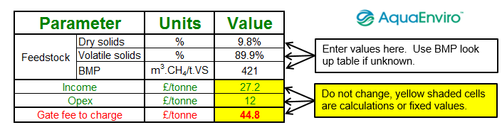

**Figure 4: Gate fee example charging model**

Components of the calculator that need to be considered include revenue from the biogas, CHP efficiency, digestate off take and other operating costs.

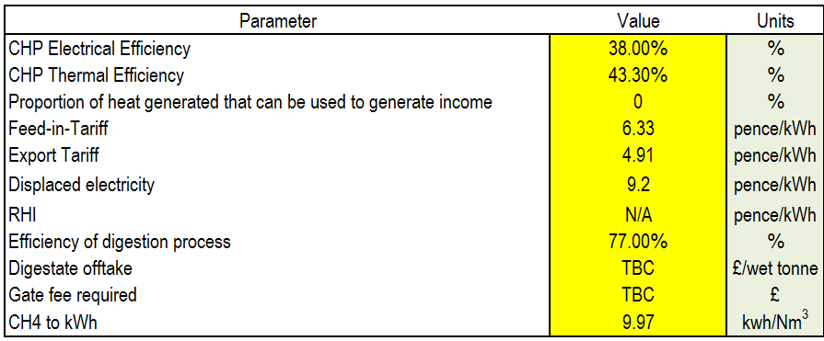

**Figure 5: Some components of a gate fee calculator**

In addition, an assessment of what proportion of the yield will be delivered needs to be made. This can be estimated based upon the prevailing hydraulic retention time and organic loading rate, including the total methane yield (BMP) and the yield associated with the digestate (termed the Residual Biogas Potential, RBP).

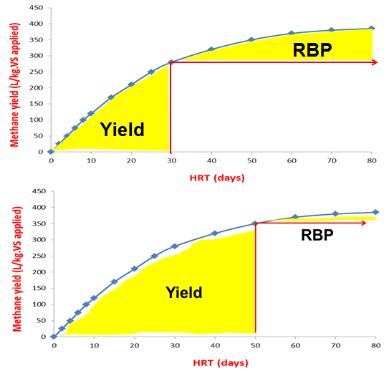

**Figure 6: Graphs showing the total biogas potential (BMP) and what is actually achieved on site and the RBP of the digestate**

Obtaining an accurate measure of feedstock biogas potential prior to accepting the waste also allows improved plant performance through better feedstock management. If the maximum potential methane yield is not being achieved, this highlights an opportunity for optimisation

**BMP data**

To assess the variability in the BMP between various feedstocks and highlight how the results can be expressed and interpreted, BMP data was reviewed from Aqua Enviro’s testing database.

1. Agricultural
2. Food waste
3. Industrial

**Results and discussion**

To achieve the full biochemical methane potential for each sample the test periods ranged from ~5-28 days, the full methane potential has been achieved once the methane evolution curve ceases to increase fig.7.

**Figure 7: Methane evolution curve illustrating the point at complete BMP is achieved (day 8)**

The following Histogram (fig.8) displays the BMP values of 150 samples collected throughout the UK from various AD sectors and feedstock categories. Considering all tests had the same mass of organics applied, this highlights the variability in potential methane yield and biodegradation rate of potential feedstocks for anaerobic digestion.

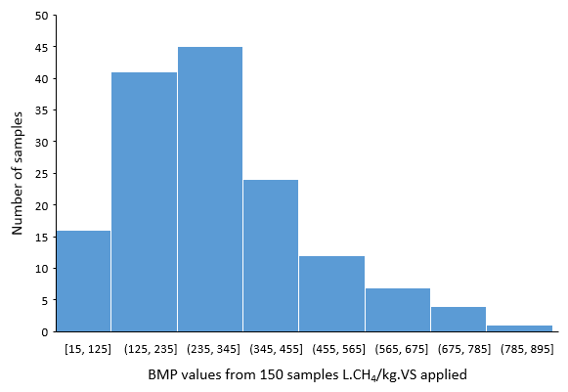

**Figure 8: BMP values from 150 samples collected throughout the UK**

Individual BMP results for certain substrate types are displayed in fig.9-11, the standard deviation was calculated for each sub group to quantify the degree of variability between each feedstock category (table 1).

There was significant variation in the BMP of the samples within each subgroup, this highlights the importance of assessing feedstocks on a case by basis, the energy value should not be quantified based on theoretical assumptions or literary values.

**Table 1: The range of BMP values and standard deviation of feedstock sub groups**

|  |  |  |  |
| --- | --- | --- | --- |
| Sample description | Units | BMP | STDEV |
| trade effluent | L.CH4/kg.COD applied | 8-315 | 87 |
| Source separated food waste | L.CH4/kg.VS applied | 108-614 | 135 |
| Cattle slurry | L.CH4/kg.VS applied | 185-254 | 22 |

**Figure 9: BMP values from cattle slurry**

**Figure 10: BMP values from source separated food wastes**

**Figure 11: BMP values from trade effluents**

**Interpretation of results**

When interpreting the BMP result from the experimental method it is important to understand the way in which the results are expressed.

Routinely the results are displayed as L.CH4/kg.VS applied, this allows for direct comparison between different feedstocks purely looking at the organic fraction of the material, not taking into account any variation of the samples dry matter content.

Fig.12 shows BMP values expressed as L.CH4/kg.COD applied, when displaying the results in this format this not only provides an indication of potential methane yield but also the % biodegradability of the substrate COD, which is calculated based on the % difference from the theoretical maximum yield achievable which is 350L.CH4/kg.COD applied Speece, R. (1996).

**Figure 12: BMP results used to indicate % biodegradable COD of 9 brewery wastes**

In the water industry BMP results are commonly expressed as m3.CH4/tds and the waste industry m3.CH4/t as received. BMP values in combination with specific site performance (for example CHP efficiency, value of the electricity and subsidies), allow for the revenue to be calculated. This is a good starting point when looking to set a gate fee. Table 2 provides a comparison for a range of feedstocks highlighting the effects of potential methane yield and dry matter content on revenue.

**Table 2: Data providing comparison between m3.CH4/tds, m3.CH4/t.as rec. and Revenue £/t of substrate**

|  |  |  |  |  |
| --- | --- | --- | --- | --- |
| sample description | m3.CH4/tds | DS% | m3.CH4 /t.as rec. | Revenue £/t of substrate* |
| Mushroom Waste | 90 | 29 | 26 | 21 |
| food waste slurry | 325 | 7 | 23 | 19 |
| Dough | 737 | 50 | 365 | 297 |
| Potato Waste | 279 | 21 | 59 | 48 |
| Coffee Grounds | 378 | 41 | 155 | 126 |
| Vegetable soup | 404 | 3 | 12 | 10 |
| Mayonnaise | 814 | 46 | 371 | 302 |
| Corn Syrup | 203 | 26 | 54 | 44 |
| Pork Pies | 307 | 69 | 211 | 172 |
| Fish waste | 453 | 34 | 156 | 127 |

*Revenue was calculated based on fig 3. Yield was multiplied by 0.00997 (Mwh/m3), then by 40% (CHP efficiency) and then by 204.40 £/MWh (feed in tariff)

*m3.CH4/t as rec. x Mwh/m3 x CHP efficiency % x Feed in tariff £/Mwh **Equation 4**

Feedstocks may have a similar methane yield based on Dry matter content but if the sample has a low solids concentration this may reduce the revenue achievable, for example if you compare the food waste slurry and pork pies substrate in table 2, although they have a similar methane yield per tonne of dry solids, as the food waste slurry DS% is significantly lower than that of the Pork pies, the difference in achievable revenue ranges from 19-172 £/t of substrate as received.

Similarly, when quantifying the value of feedstocks of an aqueous nature on a COD basis the three main factors that affect the revenue attainable from the substrate are the potential methane yield, COD concentration and readily biodegradable COD (RBCOD).

The effect of the BCOD concentration on the potential revenue attainable is highlighted by comparing Glycol waste 3 and 4 in table 3, they possess a similar COD concentration but due to the difference in BCOD from 83-97% the difference in revenue ranges from 278-328 £/t of substrate as received.

**Table 3: Data providing comparison between COD kg/m3, m3.CH4 /t.COD, m3.CH4/t.as rec. and Revenue £/t of substrate**

|  |  |  |  |  |  |
| --- | --- | --- | --- | --- | --- |
| sample | COD kg/m3 | m3.CH4/t.COD app. | % RBCOD | m3.CH4/t.as rec. | £/t of substrate |
| Glycol waste 1 | 1230 | 198 | 57 | 244 | 199 |
| Glycol waste 2 | 598 | 221 | 63 | 132 | 108 |
| Glycol waste 3 | 1186 | 339 | 97 | 402 | 328 |
| Glycol waste 4 | 1180 | 289 | 83 | 341 | 278 |
| Glycol waste 5 | 1381 | 350 | 100 | 483 | 394 |
| Glycol waste 6 | 1160 | 14 | 4 | 16 | 13 |
| Glycol waste 7 | 1445 | 194 | 55 | 280 | 229 |
| Glycol waste 8 | 1030 | 131 | 37 | 135 | 110 |
| Glycol waste 9 | 196 | 78 | 22 | 15 | 12 |
| Glycol waste 10 | 1760 | 272 | 78 | 479 | 390 |
| Glycol waste 11 | 1521 | 320 | 91 | 487 | 397 |

**Summary**

Previous studies have shown that certain methods utilised to determine the energy yield from a feedstock do not provide an accurate quantitation of the potential methane that can be produced, as they do not take into account biodegradability or potential inhibitory properties that a feedstock may possess.

This study has shown there is a high degree of variation between feedstocks of a certain subgroup such as source separated food waste and trade effluents. BMP data can be used to indicate methane yield and biodegradability potential.

When an accurate measure of the biochemical methane potential is required for substrate pre-screening, plant design or the assigning of gate fees, the experimental method for BMP is an invaluable tool to assess the energy value of a feedstock for anaerobic digestion.

**References**

Labatut, R. Largus T. Angenent, L. Scott, N. (2011). Biochemical methane potential and biodegradability of complex organic substrates. *Bioresource Technology* 102, 2255–2264

McCarty, P. (1972). Energetics of organic matter degradation. *Water Pollution Microbiology* pp. 91–118.

Walker, M. Zhang, Y.Heaven, S. and Banks, C. (2009). Potential errors in the quantitative evaluation of biogas production in anaerobic digestion processes. *Bioresource Technology* 100, 6339–6346

Symons, G.E., Buswell, A.M., (1933). The methane fermentation of carbohydrates. *J.Am. Chem. Soc*. 55, 2028–2036.

Speece, R. (1996). *Anaerobic Biotechnology for Industrial Wastewaters.* Archae Pr, Nashville

Standing Committee of Analysts. (1978). *Amenability of sewage sludge to anaerobic digestion, 1977. Methods for the examination of waters and associated materials.* H.M.S.O, London.

Wellinger, A. Murphy, J. and Baxter D. (2013). *The Biogas handbook science, production and applications.* Woodhead publishing, Oxford

Thomas, E. (2016). AD map [online]. *The Anaerobic Digestion & Bioresources Association.* <http://adbioresources.org/map> [accessed 11/11/2016]

Morton, C. (2016). *Anaerobic digestion market report* (2016) <http://www.ciwm-journal.co.uk/wordpress/wp-content/uploads/2016/07/marketreport2016-44a4_v1.pdf> [accessed 11/11/16]

Wrap (2016). *Comparing the costs of waste treatment* options <http://www.wrap.org.uk/content/gate-fees-report-2016> [accessed 11/11/16)